I used React for the simple design, MySQL database to store the family members information, node.js to connect the local database that I created to my project file and Java script to incorporate all of it in a function.

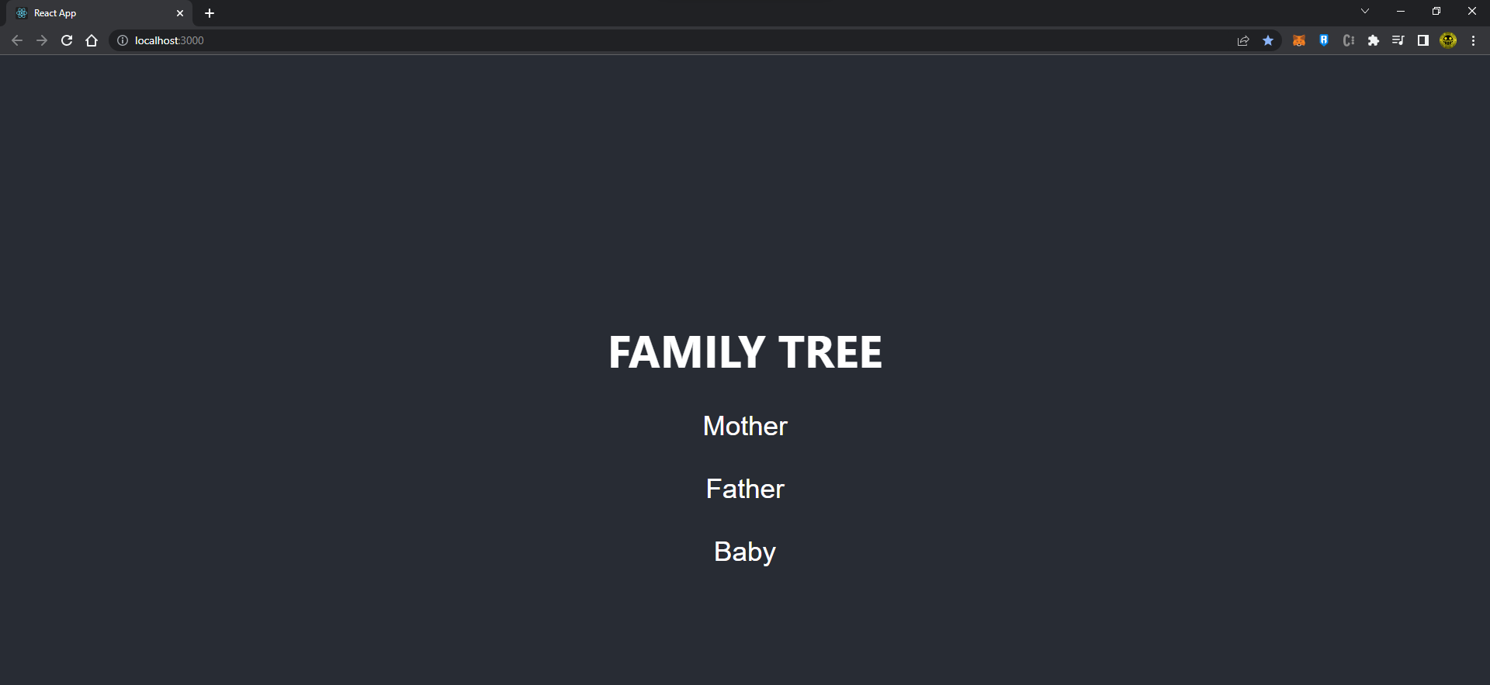

Results based on the Family member that has been click by the user.

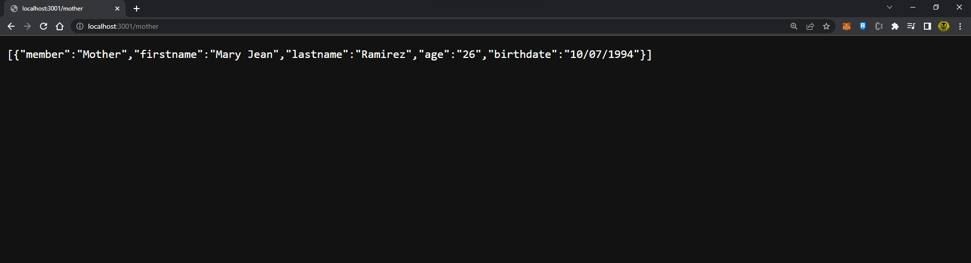

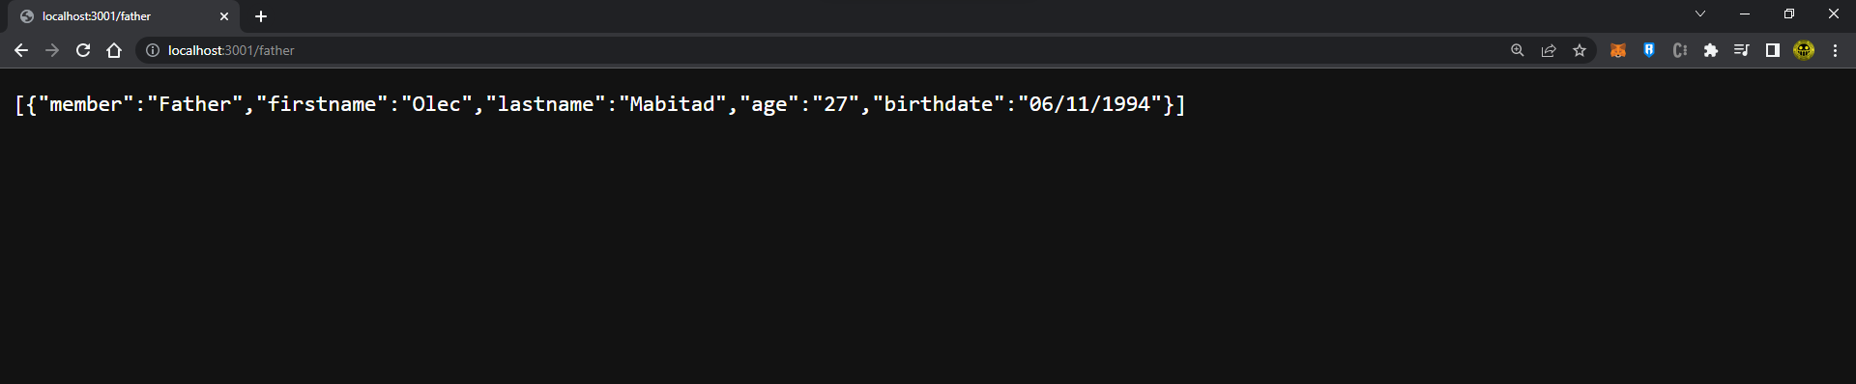

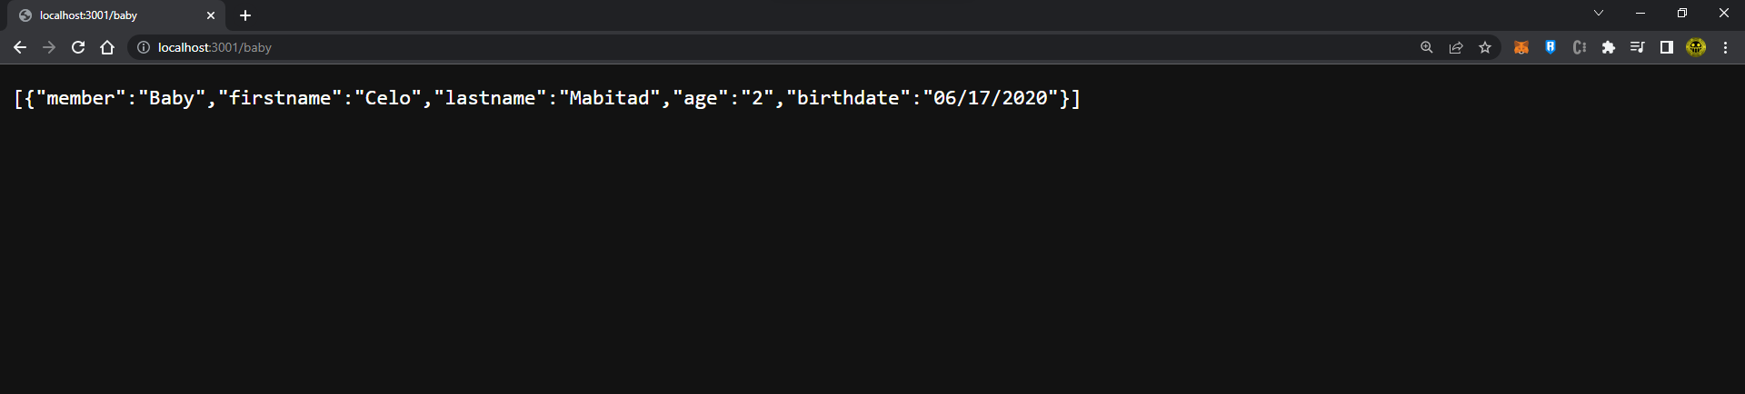

The details are based on the database that I created for each family members.

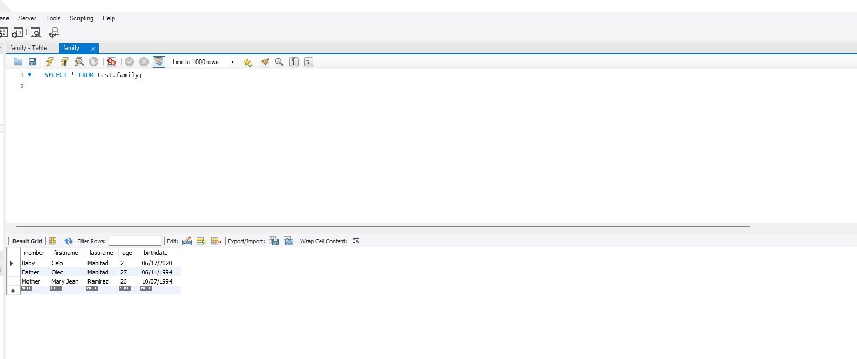

I used a SQL connection to my local database and nodemon command to run the script.

